Jon Janelle

MAT 500

9/13/2013

**Chapter 3 Exercises**

**3.1** The graph shows that the sample proportion of heads approaches the theoretical proportion

p(H) = 0.8 as the number of trials becomes large. The dotted reference line is drawn at p(H) = 0.8.



**3.4**  **(A)** The following plot shows the approximate area under the normal curve from $x=μ-σ$ to $x=μ+σ$. The probability mass under the normal curve in this interval is approximately 0.689.

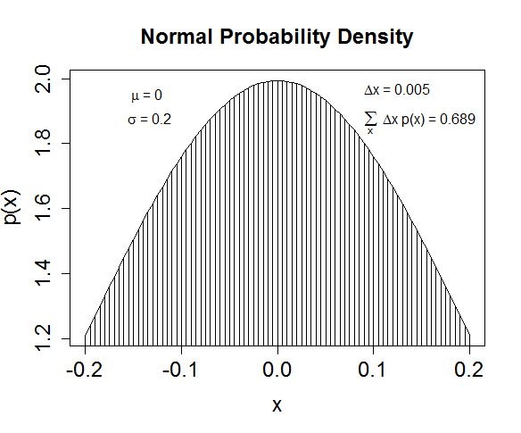

**(B)** As the graph in part A shows, approximately two-thirds of the probability mass falls between $x=μ-σ$ and $x=μ+σ$ if the data are normally distributed. This means that the belief is that the distribution of women’s heights is normal with a mean of 162cm and a standard deviation of approximately 177cm -162cm = 15cm.